Data Collection ---- Web scraping
- HTML.parser ;
Raw Webpage text ----> Structured HTML

- Functions of BeautifulSoup
-Using for converting raw webpage content into navigable tree structures --->HTML parsing
-Handling Malfuctioned HTML
-used for filtering web context -----> find(), find_all()
-Extracting data from the webpage ----> get(), get_text()
-It also helps to navigate the tree parse ----> allows the web scraper to get the siblings and the descendants;
Parents ---> Siblings ---> Descendants.
- Locating the HTML tags to extract from;
- using the find(), find_all() ;
E.g scrape = response.find_all(‘div’, class=’contentfpa’)---> the bs finds all the divs with the class of contentfpa.
-storing the csv file ;
with open("countries_scraped.csv", "w", newline="", encoding="utf‑8") as f:
With - ensures that the file is automatically closed after the wrting is finished.
-with statement is used as a context manager it calls both __enter__() and __exit__(), so you don’t have to manually close the file even incase of errors.
- open() --> the function takes 2 params; filename and mode ; e.g, with open(‘efile.txt’, ‘w’)

--List comprehension..
--pandas ??
--https://github.com/practical-tutorials/project-based-learning

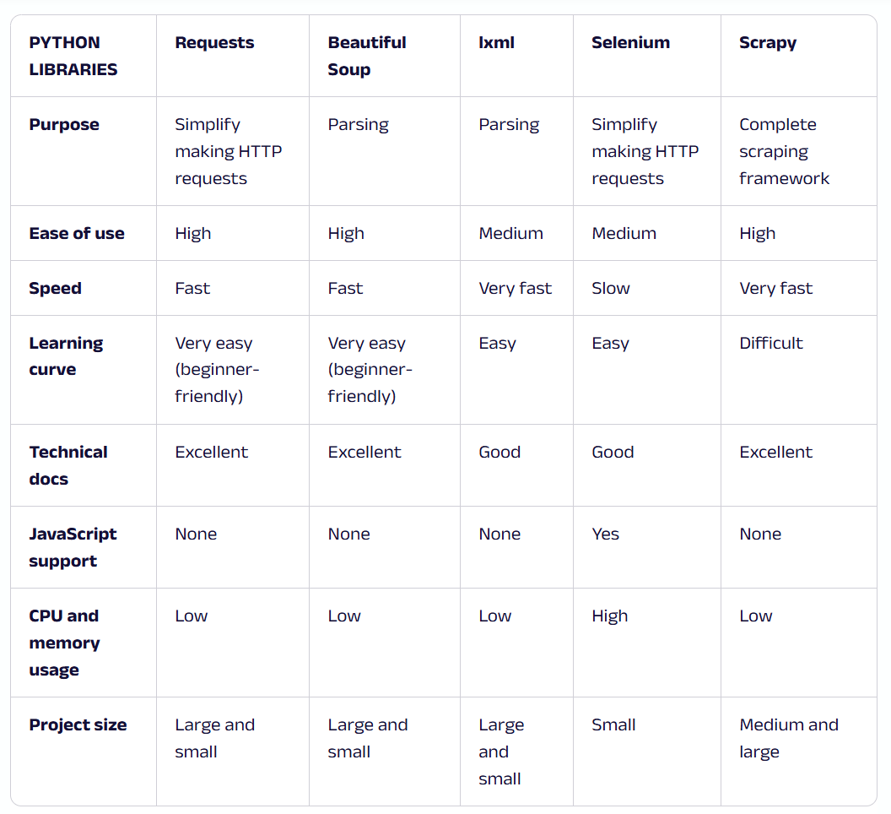
---scrapy---https://thepythonscrapyplaybook.com/freecodecamp-beginner-course/freecodecamp-scrapy-beginners-course-part-4-first-scraper/
--BeautifulSoup--https://www.crummy.com/software/BeautifulSoup/bs4/doc/#installing-a-parser

